1. **Analysis 1**

1) Perform general Data analysis  
 2)Can you tell me the Distribution of Vehicles based on Year of Registration with the help of a plot

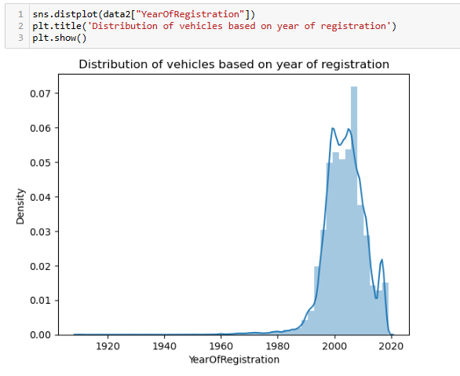

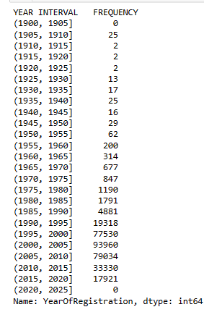

* There is heavy registration of vehicles from 1990 to 2020
* There is increase in registration of vehicles from 1915 to 2005 and after that count has been decreased
* No vehicle has been registered after 2020

3) Create a plot based on the Variation of the price range by the vehicle type

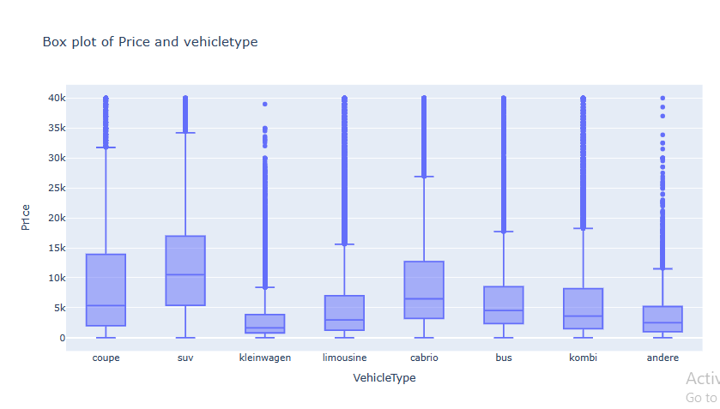

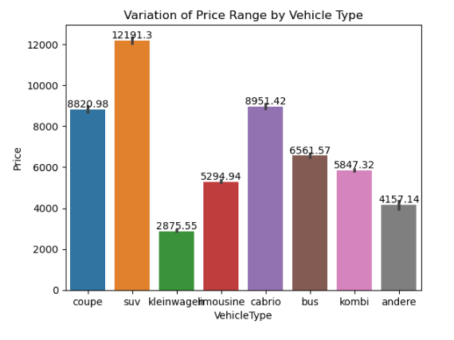

* “kleinwagen” and “andere” vehicle types are available in low price range compared to other vehicle types
* “suv” vehicle type is mostly available between the price range $1500 and $9400
* Almost all the vehicle types maximum price is $20k

4) Find out Total count of vehicles by type available on ebay for sale.As well as create a visualization for the client

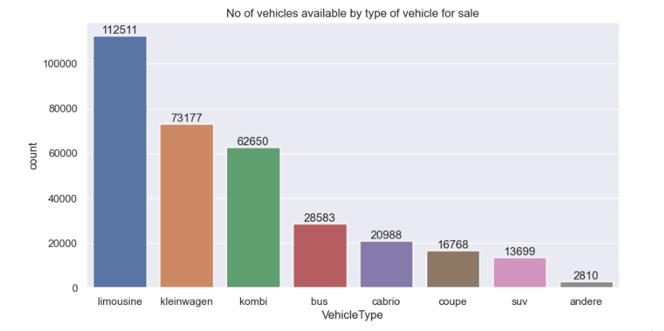

* “limousine” vehicle type is available mostly in ebay used cars in Germany and next vehicle type available is “kleinwagen”.
* “andere” vehicle type is available at least.

5) Is there any relationship between dollar_price and kilometer? (Explain with appropriate analysis)

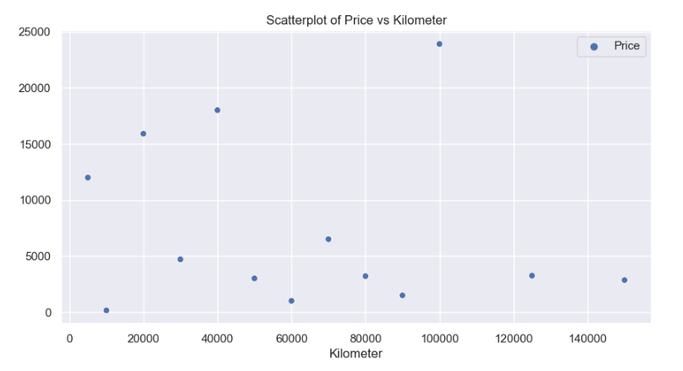

* There exists a negative correlation between price and kilometer .
* The correlation is -0.44 which indicates that as the Kilometer and price are not highly correlated.
* As the kilometer is increasing there is a small decrement in price.